Project Structure

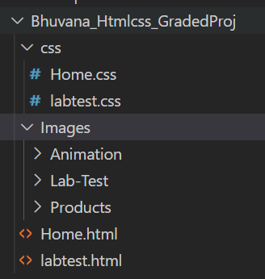

1. Create a Header (“Pharmacy”) and Footer(“@copyright. Only for demonstration purposes”).

Header

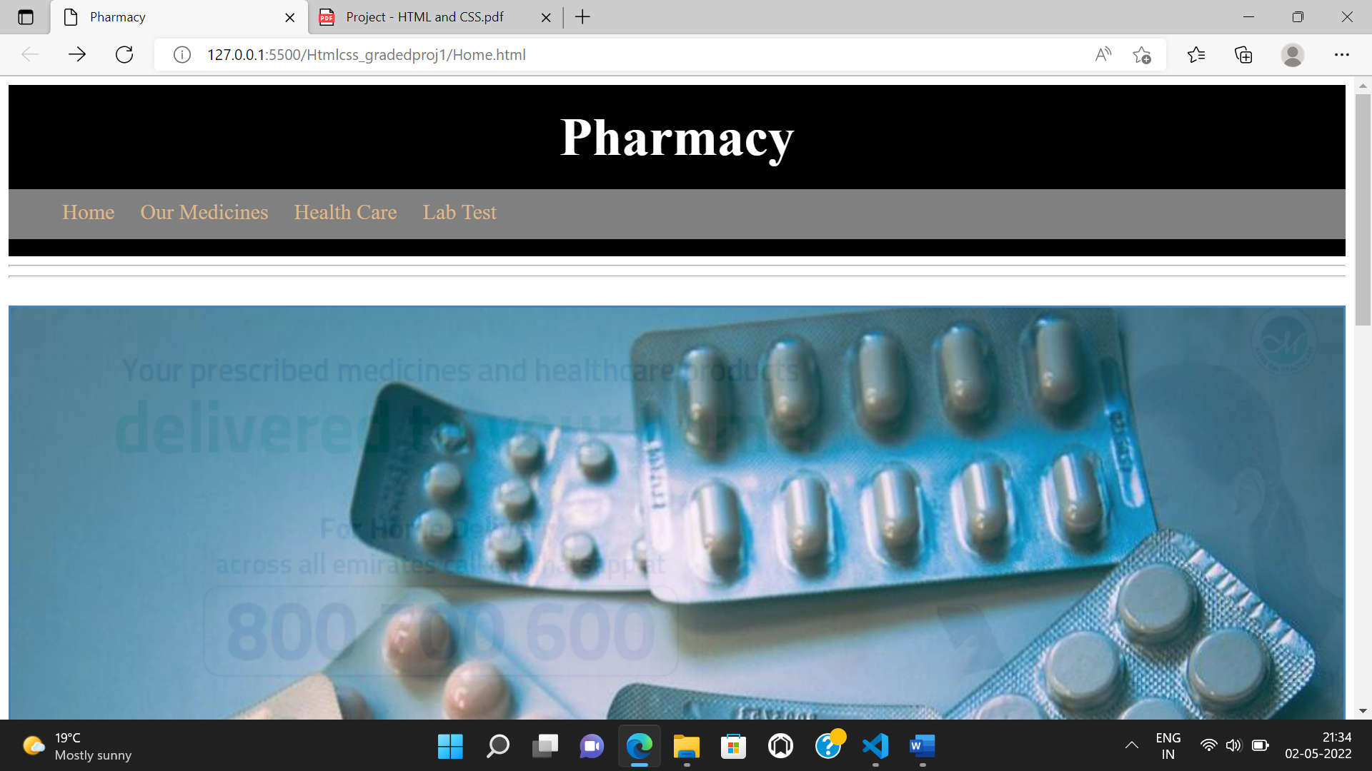

Footer

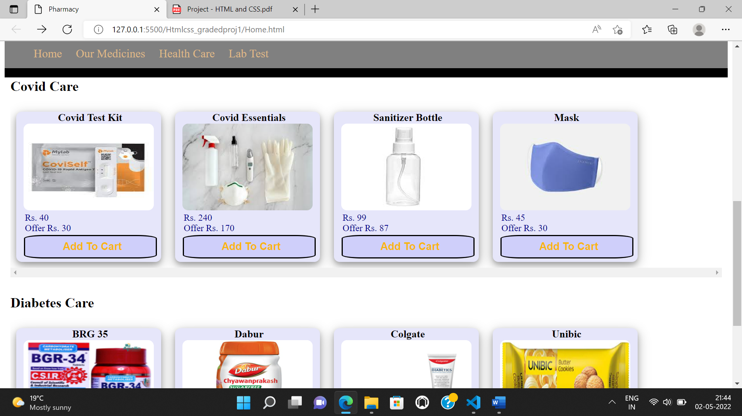

2. Create a Horizontal Navigation Bar after Header with required tags to link. When hovering on any of the links, make sure the background color changes accordingly. The tag names are as Follows. a. Home b. Our Medicines i. When Hovered on this, show a dropdown list of links for Fever, Muscle Pains, (Cold & Cough) c. Health Care i. When Hovered on this, show a dropdown list of links for Baby Care, Skin Care, Home Care, Personal Care and Pet Care d. Lab Test i. When Clicked on Lab Test, Open a form to book the slot. e. When the web page is scrolled, make sure that the navigation bar is still seen on the top of the web page. (Look at the below images for your reference.)

Horizontal Navigation Bar after Header with required tags , When hovering on any of the links, make sure the background color changes

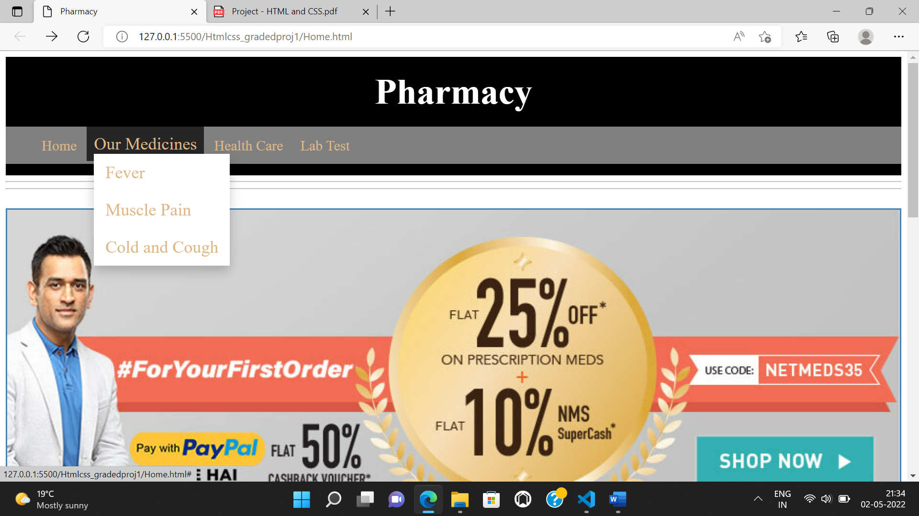

show a dropdown list of links

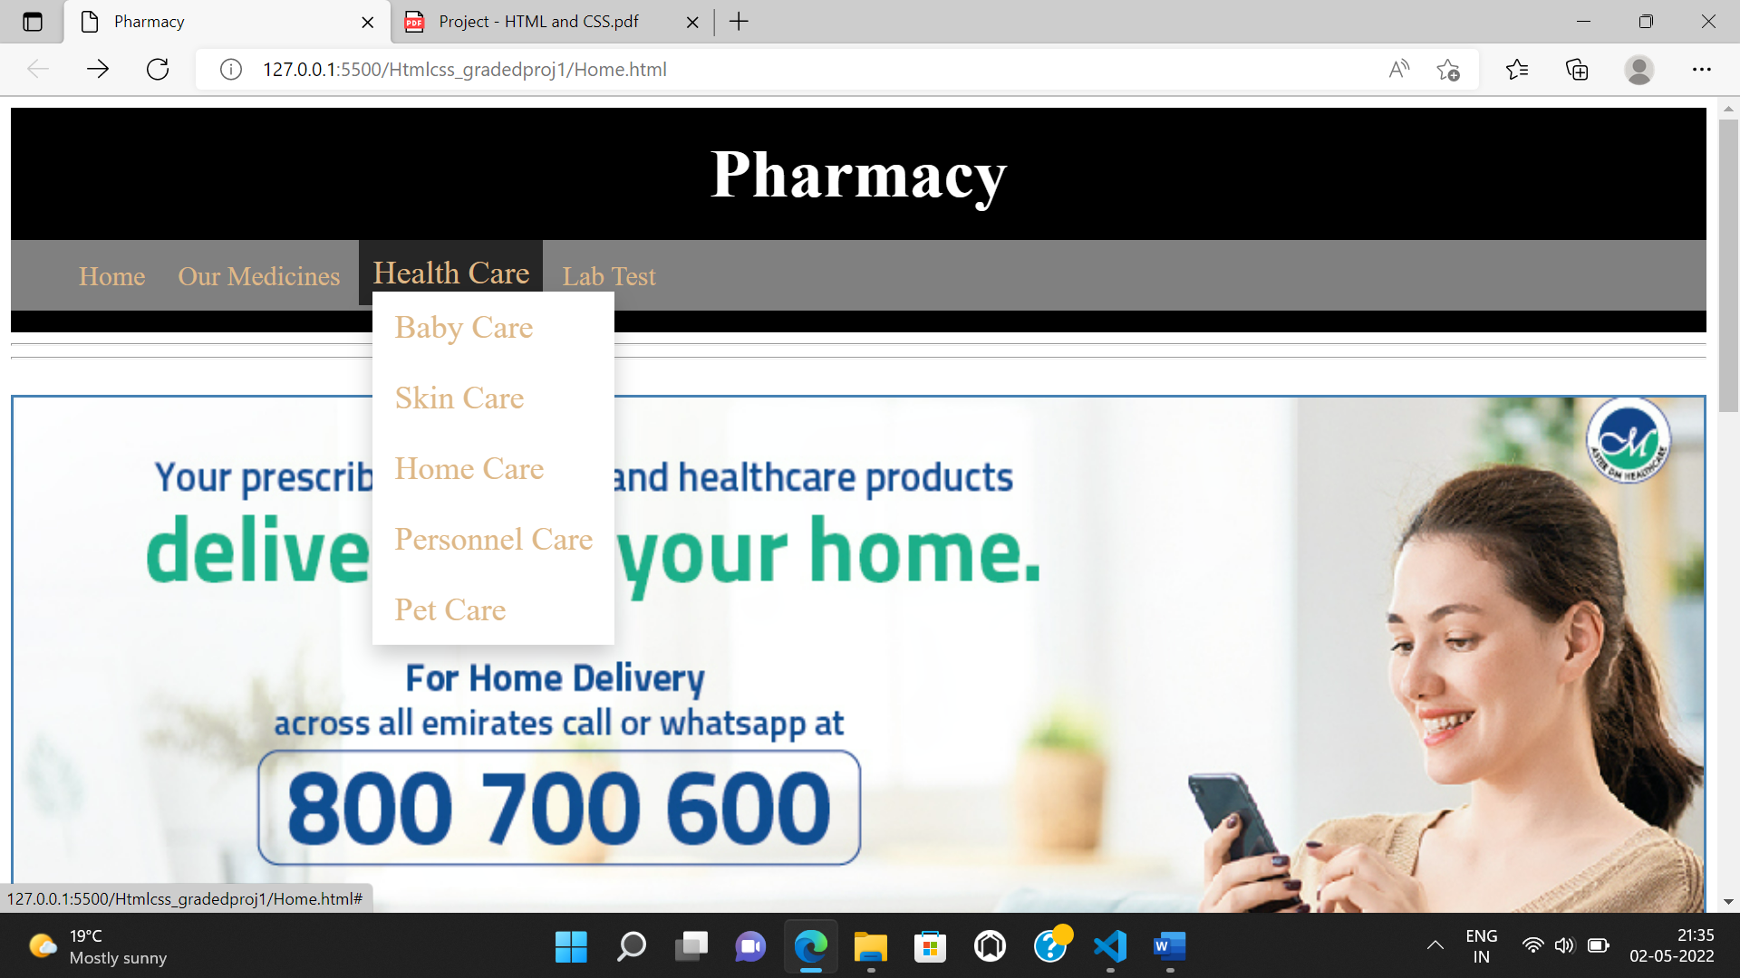

When Clicked on Lab Test, Open a form to book the slot

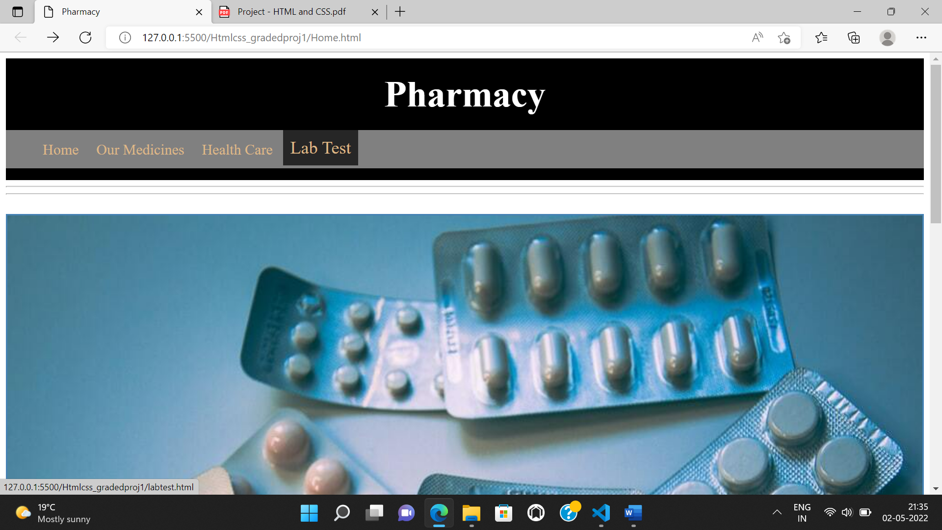

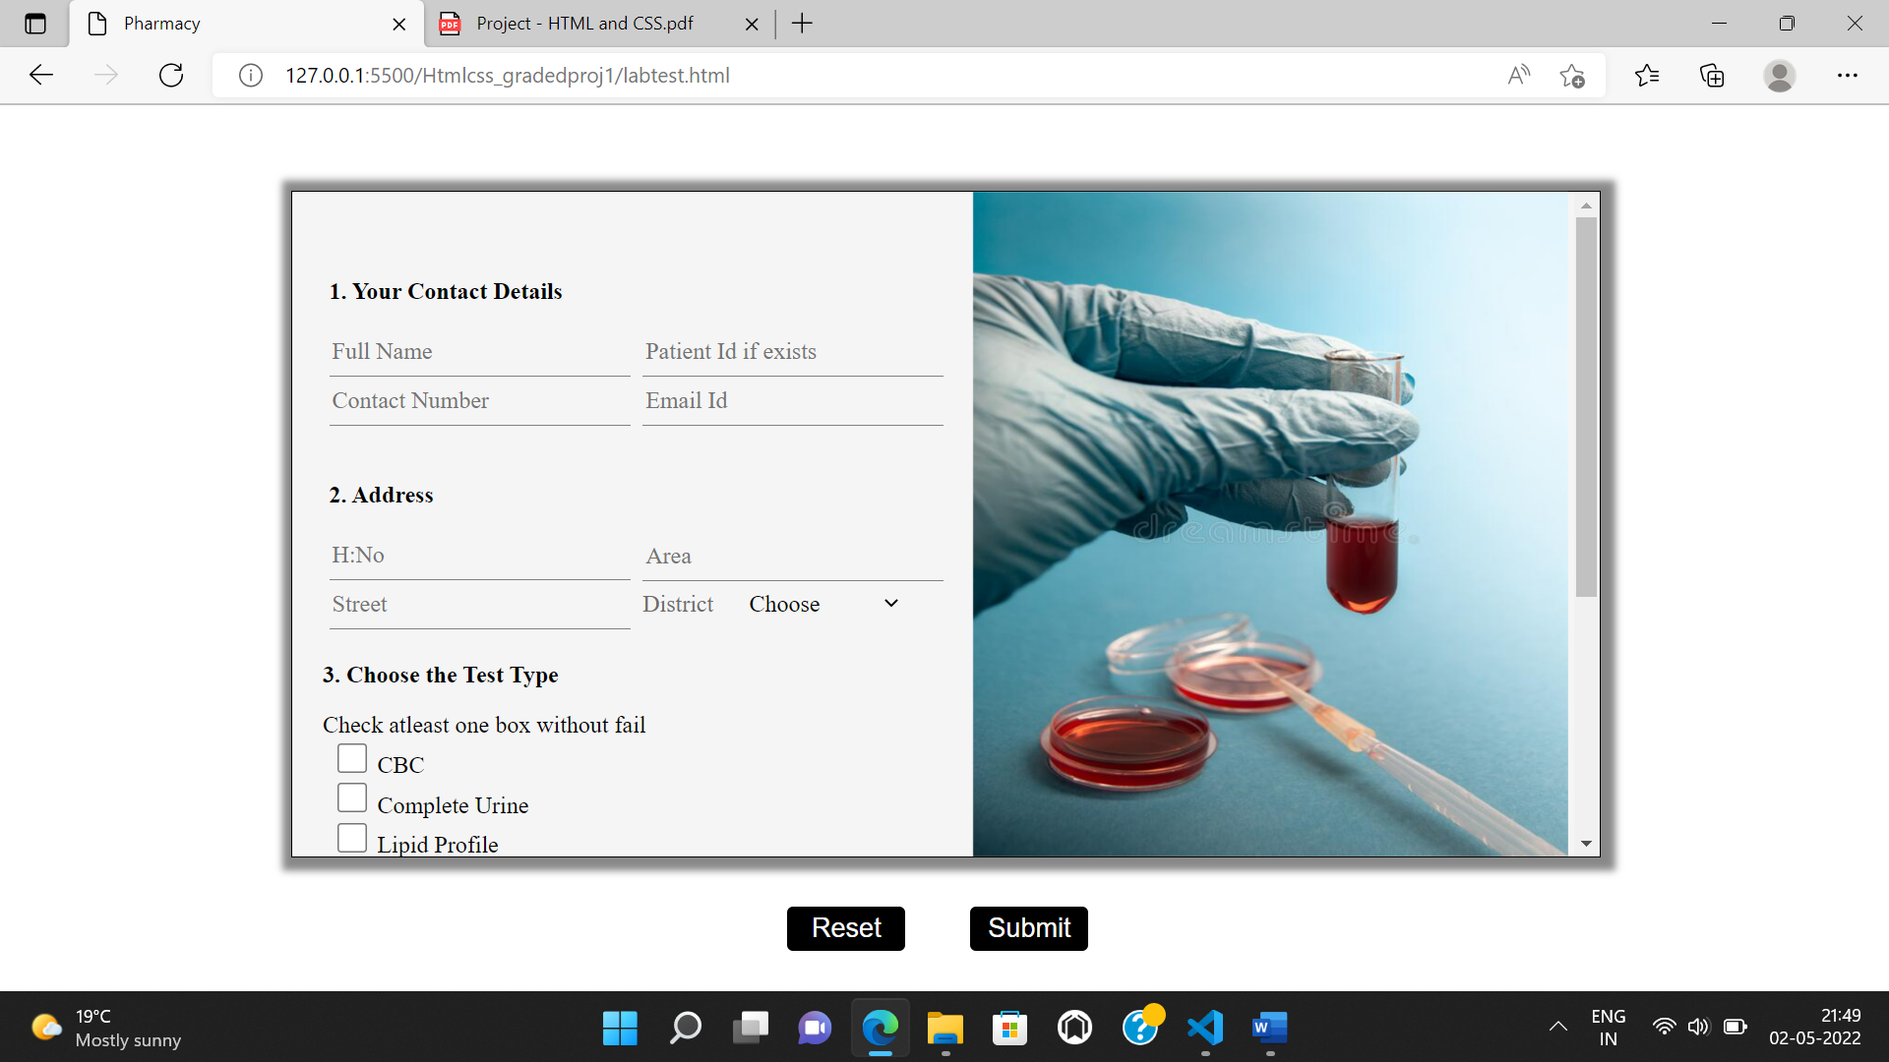

When the web page is scrolled, the navigation bar is still seen on the top of the web page

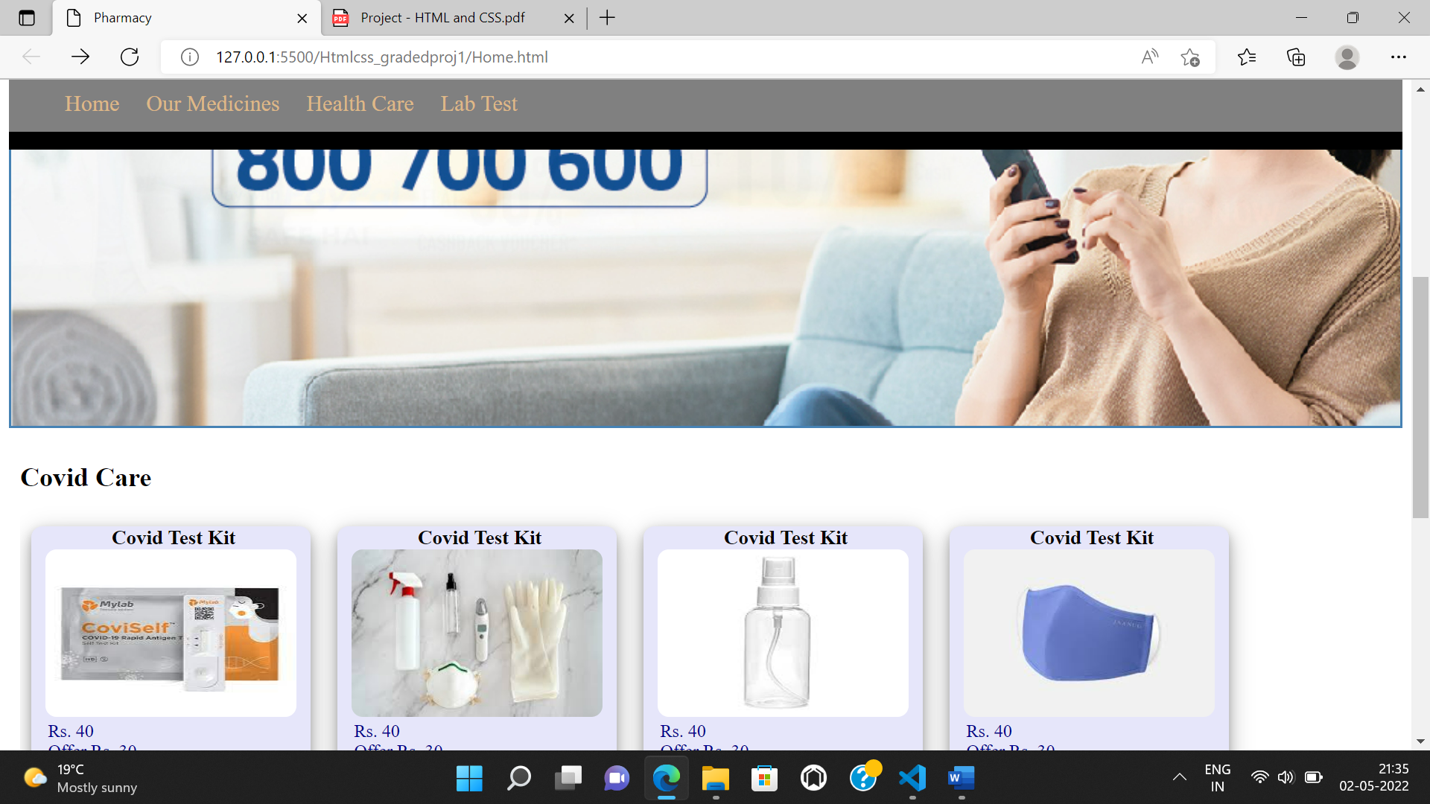

3. First thing in the web page is to show offers or some information in the form of images. a. Use the Images given in the project file and create a simple animation to show them one after the other infinite times. Apply a border of 2px solid steelblue.

Animations applied – Ad’s shown infinite times

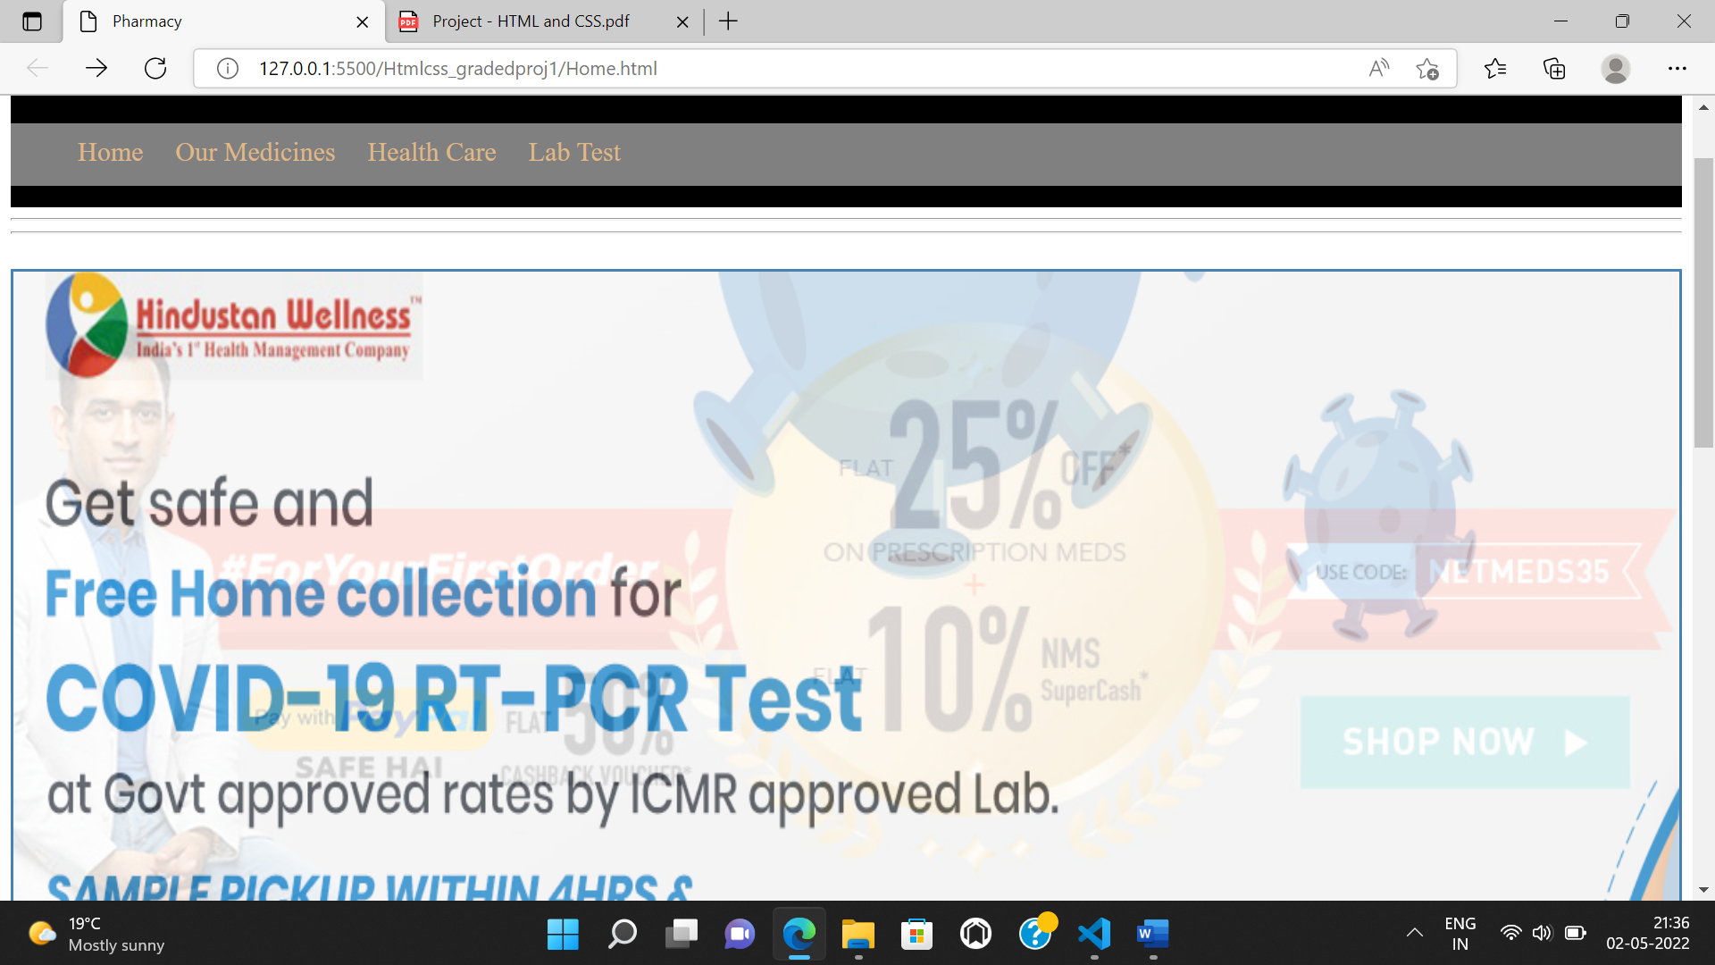

4. Next, create two sample sections of the products as Covid Care and Diabetes Care.

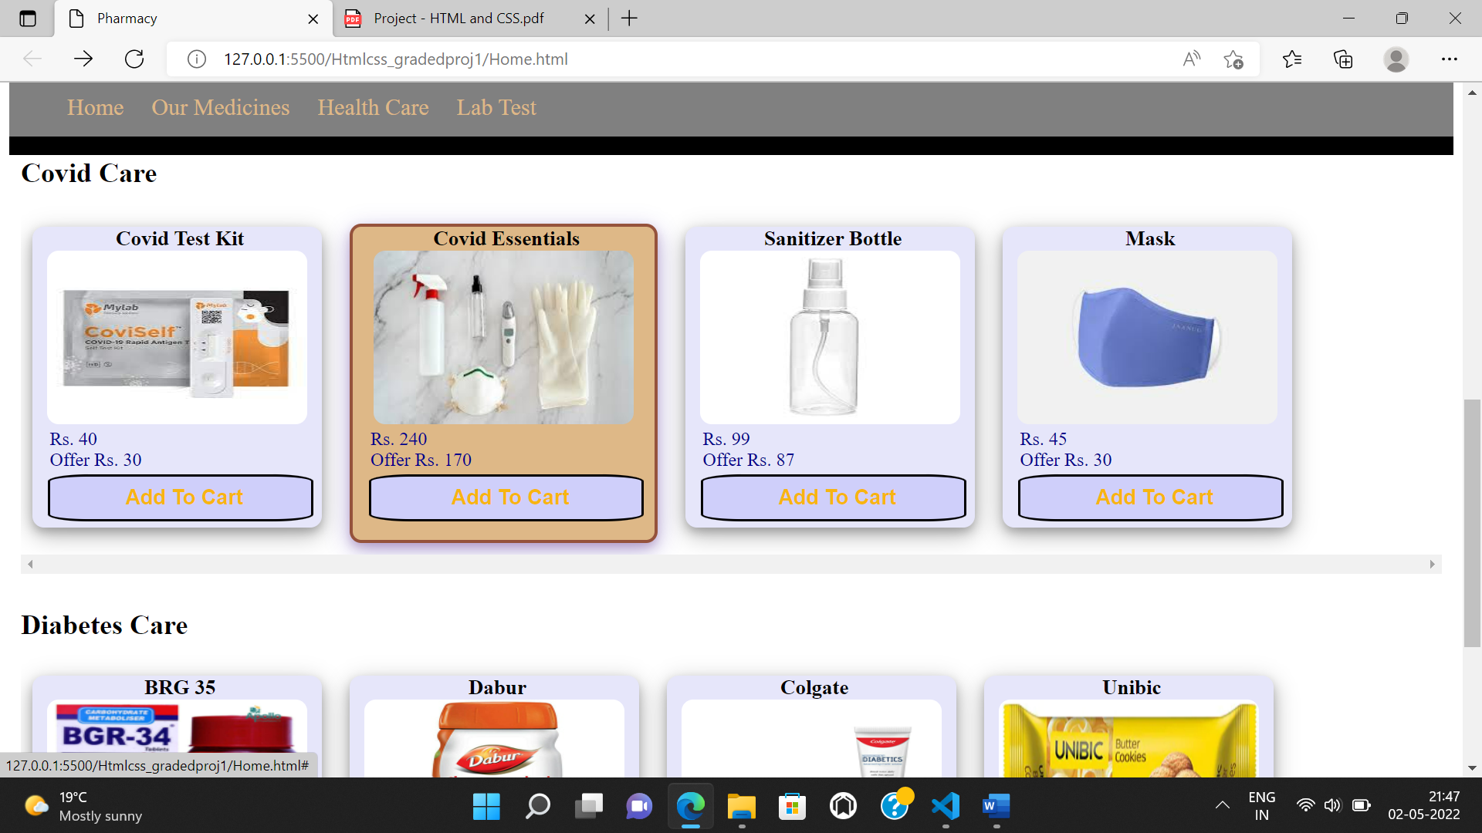

5. Under Each of them display products with product name, image, Price and Price after Offer and a Add to Cart option. When clicked on the button, the background color should change to rgb(250, 234, 230) and the border should change to rgb(0, 255, 76). When hovered on each product, slightly increase the width and height of it. Make Sure the output looks as shown below.

When AddToCart button clicked, Background color and font size of button changed as per specification.

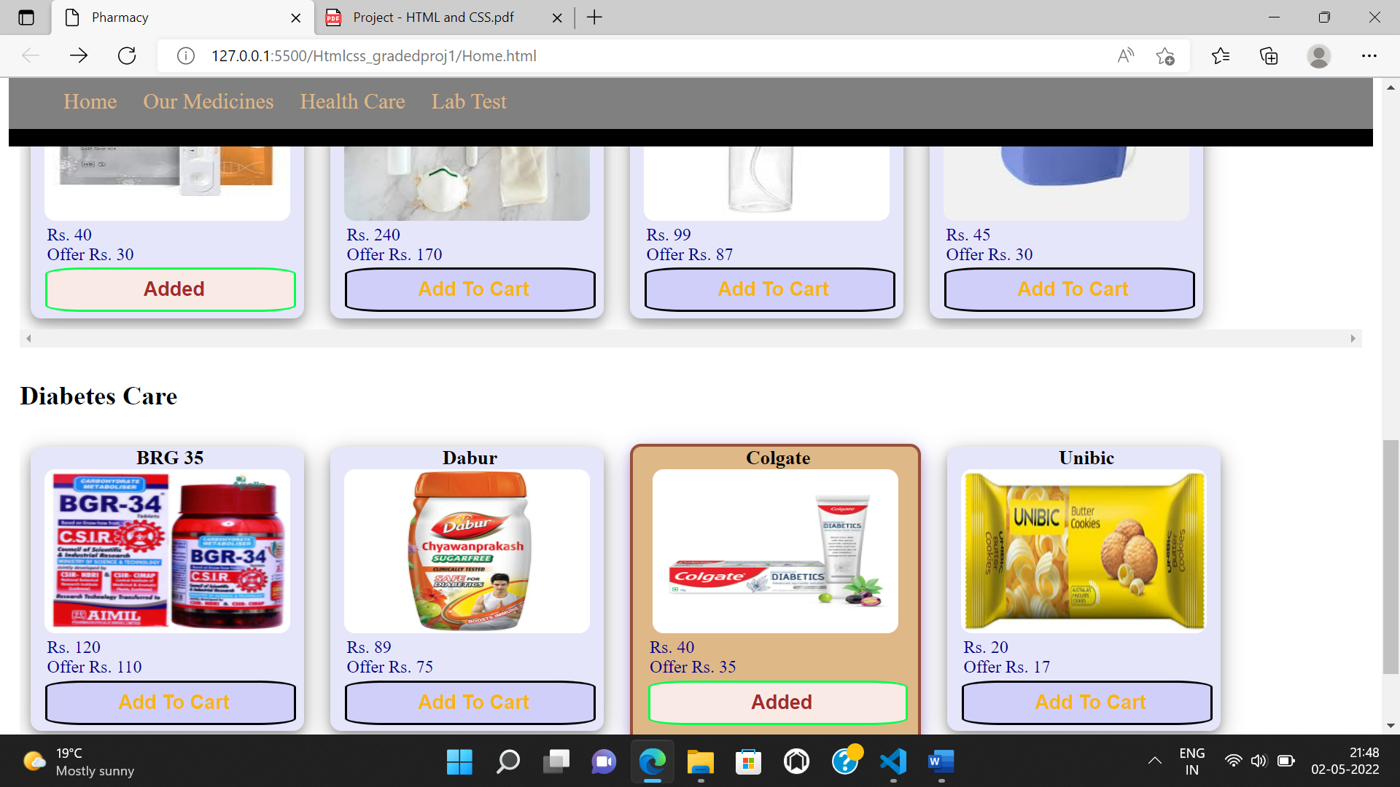

6. When clicked on Lab Test in the Navigation bar, a form shall open with validation in a new page with following details. a. Form shall have Patient Contact Details as follows. i. Full Name ii. Patient Id if exists iii. Contact Number iv. Email Id b. Address i. House Number ii. Street iii. Area iv. District (List. Make Sure first option is “Choose”) c. Choose the Test Type. Show a message (Check atleast one box without fail) i. CBC ii. Complete Urine iii. Lipid Profile iv. Thyroid Stimulating Hormone(TSH) v. Glucose Test d. Do you want a hard copy of the report also? i. Yes ii. No e. Select Your Comfortable Date and Time i. Date ii. Time f. Reset and Submit button

Lab-test form



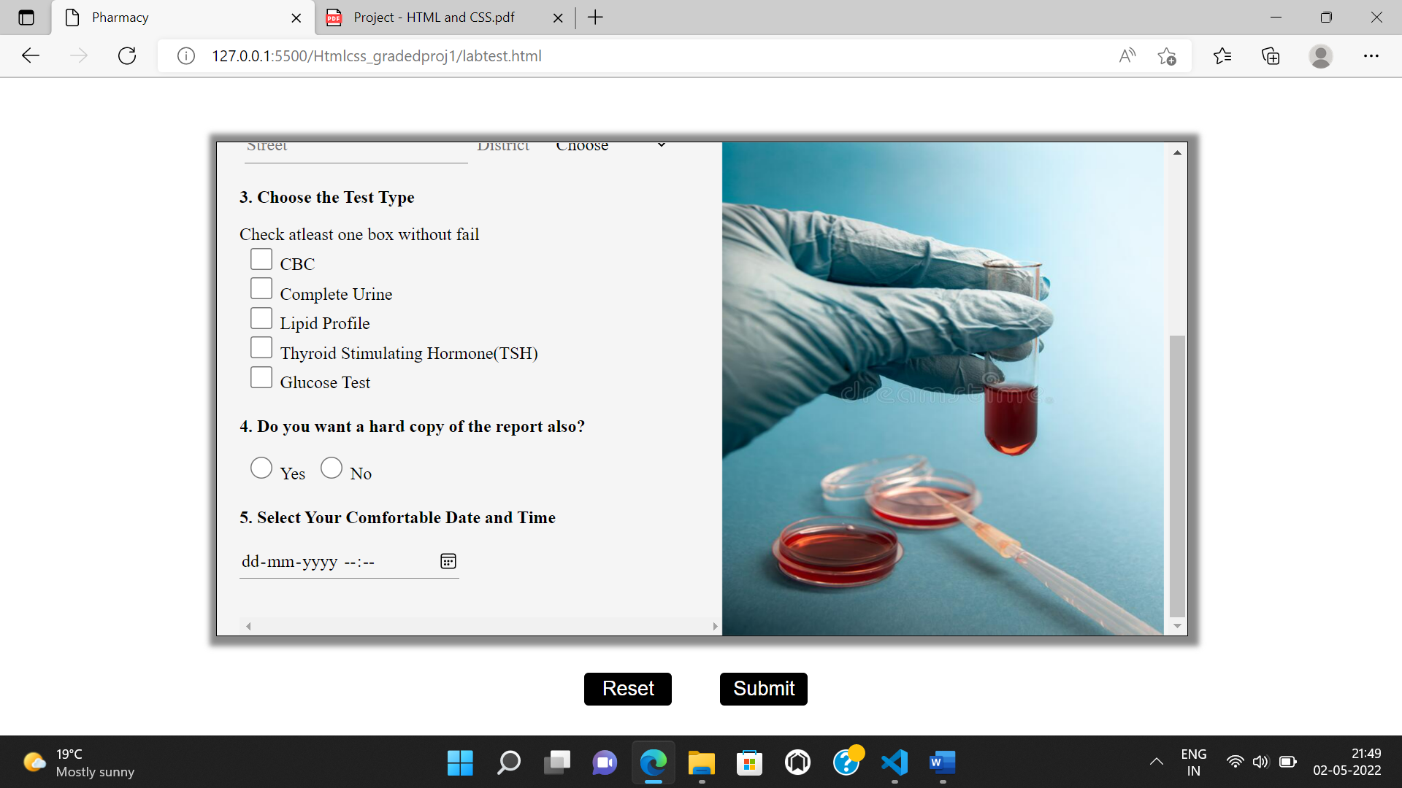

Validations applied when submitted

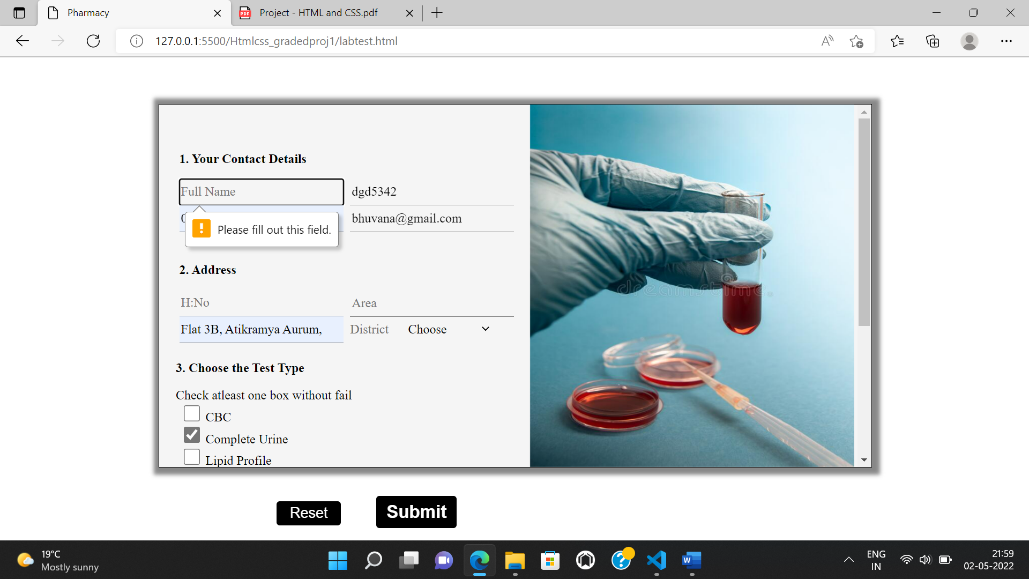

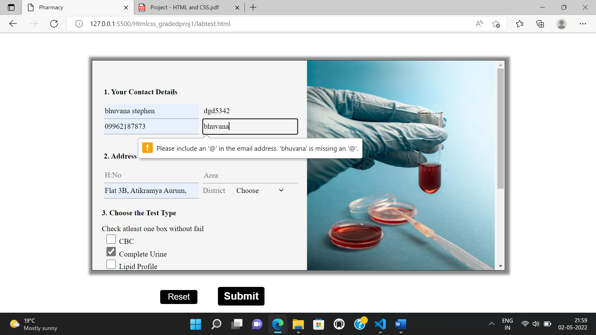

Responsive when page is resized

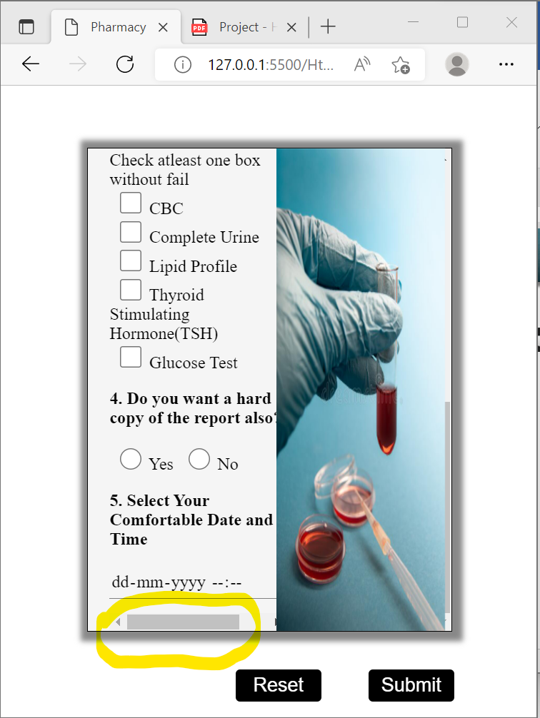

Reset Button

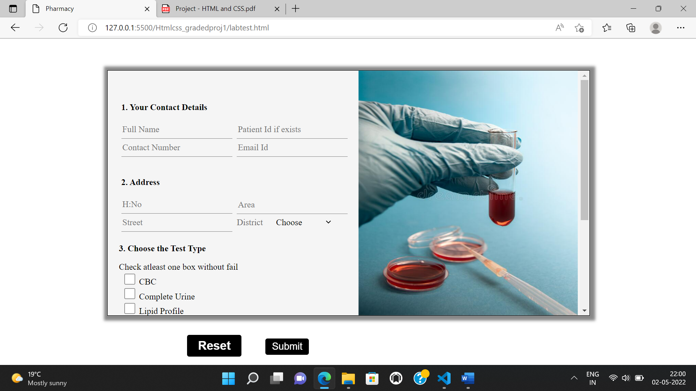

7. On the Right Side of the form insert an image which will not move when you scroll the page. Make Sure Your form looks as below.

Right side image not moving when form is scrolled

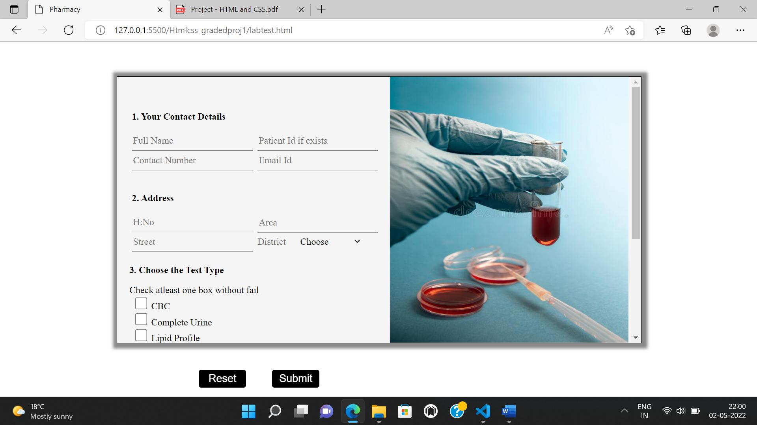

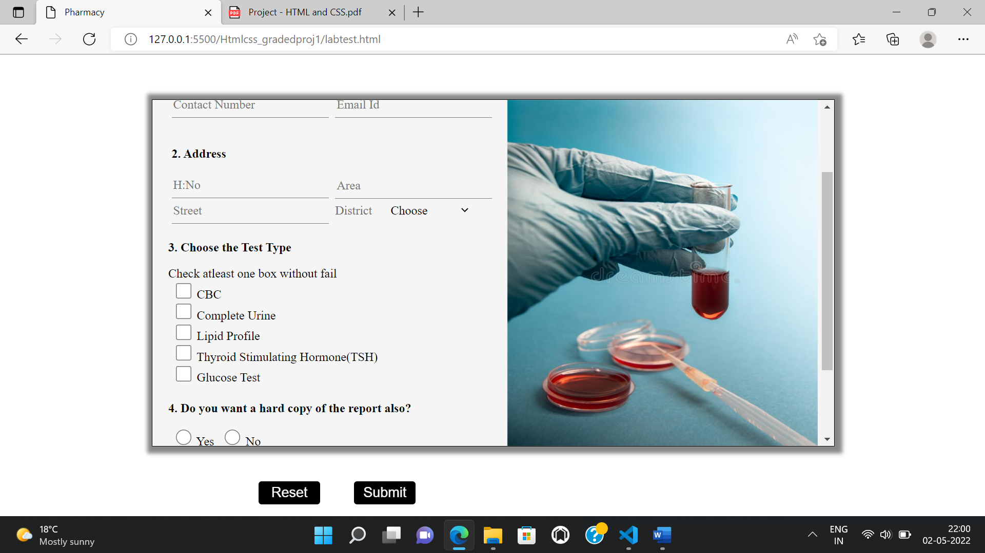

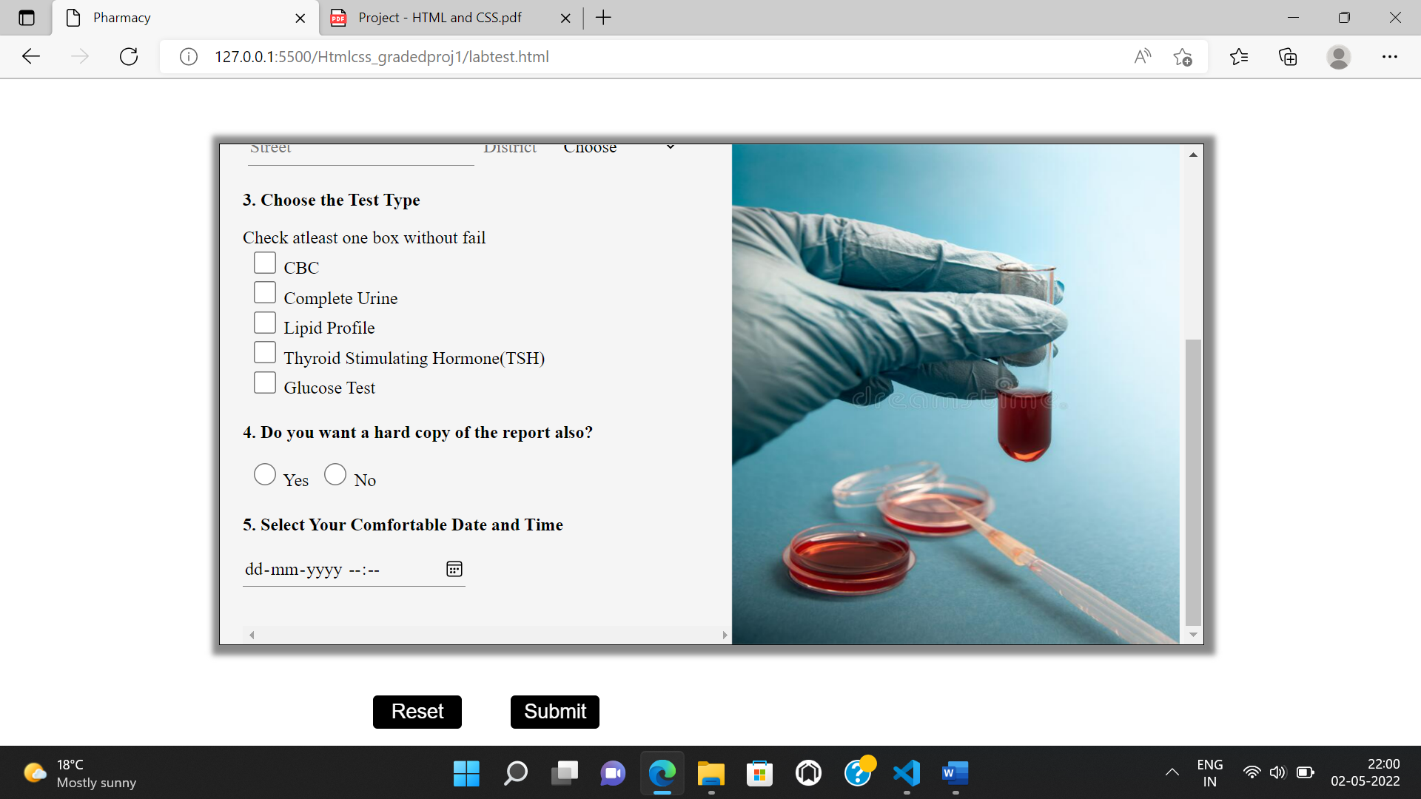

Thank You